

Creating a Google Play API Key
Scriptoria Admin Help

Introduction
Scriptoria allows the automated publishing of Android apps to the Google Play Store. In order to do this, Scriptoria needs a Google Play API Key from the organization for each Google Play Store account. Only the owner of the Google Play Developer Account can perform these steps. This document provides guidance specific to Scriptoria.

Full documentation from Google is available at: https://developers.google.com/android-publisher/getting_started

In 2023, Google removed the API access page from the Google Play Console. In their documentation (above), they say: "Note: You no longer need to link your developer account to a Google Cloud Project in order to access the Google Play Developer API."

Now you first need to create a Google Cloud Project (one can be used for multiple Google Play Store accounts)

Steps

Create a Google Cloud Project
Go to the Google Cloud Console https://console.cloud.google.com and either use an existing project or create a new one. You can have more than one Google Play Store configured in a Google Cloud Project. If this is your first time accessing Google Cloud, you will need to read and agree to the Terms of Service.

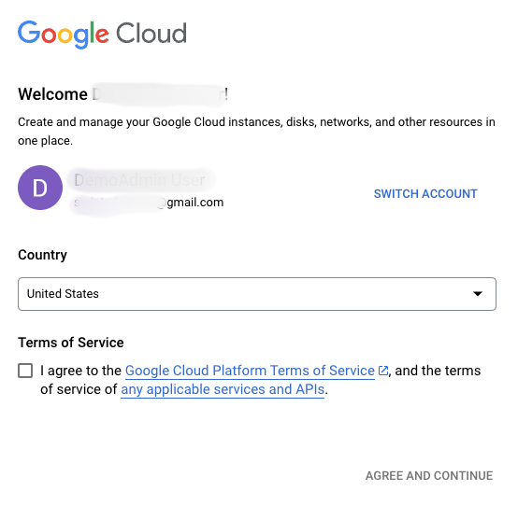
To create a project:

- In the menu bar of the website, click on the Select a project dropdown.

- In the Select a project dialog, click on the NEW PROJECT link

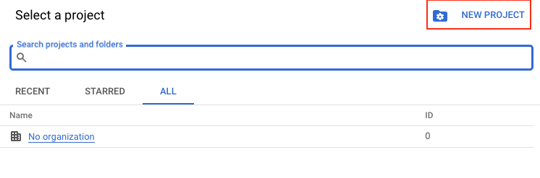
- In the New Project page, enter a Project name (e.g. Google Play Console Developer). You may select an organization or not assign an organization. It is up to you.

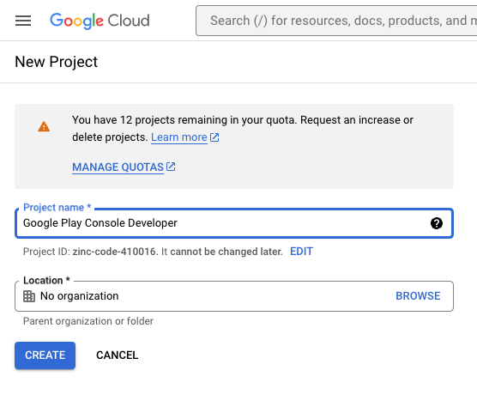

Select the Project
To select a pre-existing project or the newly created project:
- In the menu bar of the website, click on the Select a project dropdown.

- In the Select a project dialog, click on the link for the project name.

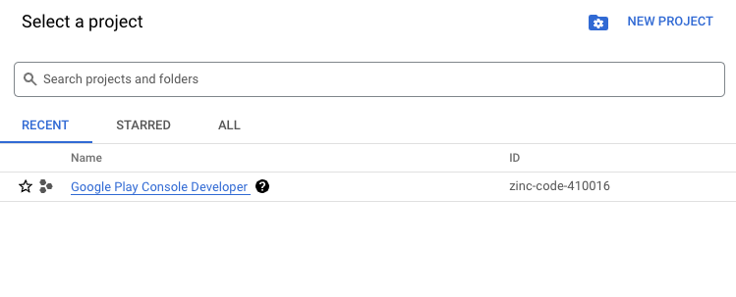
You should now see the project name displayed in the Select a project dropdown.

Enable the API
Once you have set up the Google Cloud Project, you need to enable the Google Play Developer API for this project. This is only for new projects.

To enable Google Play Developer API:
- Go to the Google Play Developer API page in Google Cloud Console.
- Click Enable.

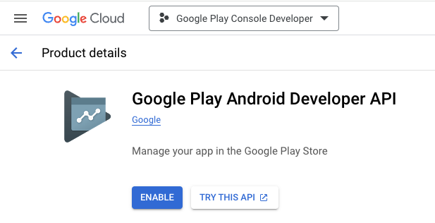

Create Service Account
For Scriptoria to publish to Google Play on your behalf, you will need to create a service account. A service account is created in the IAM & Admin section of the Google Cloud Console. To navigate to the this section, you can:

- type "Service Accounts" in search field or

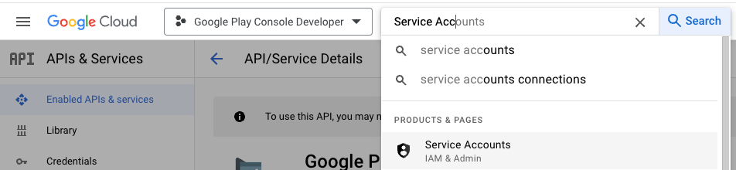

- click on the search field and then click on IAM & Admin in the POPULAR SEARCHES list and then select Service Accounts from the menu on the left.

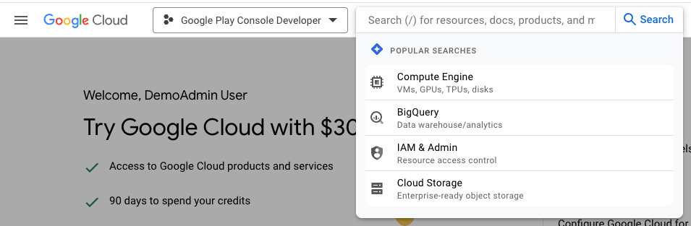

- Click on + CREATE SERVICE ACCOUNT
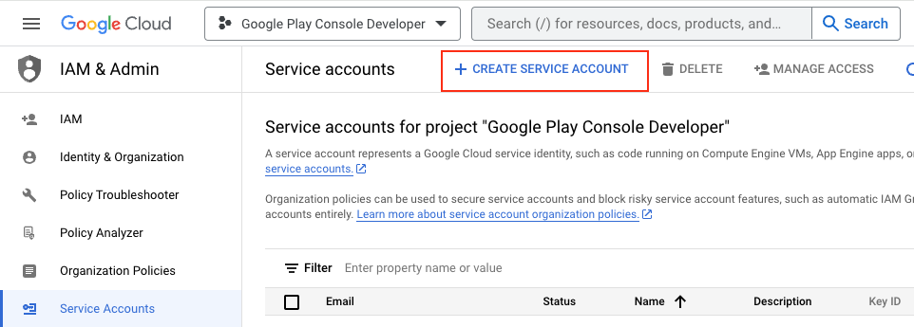
- Enter a Service account name (e.g. YOUR_ORG_NAME-scriptoria) and Service account description (optional)
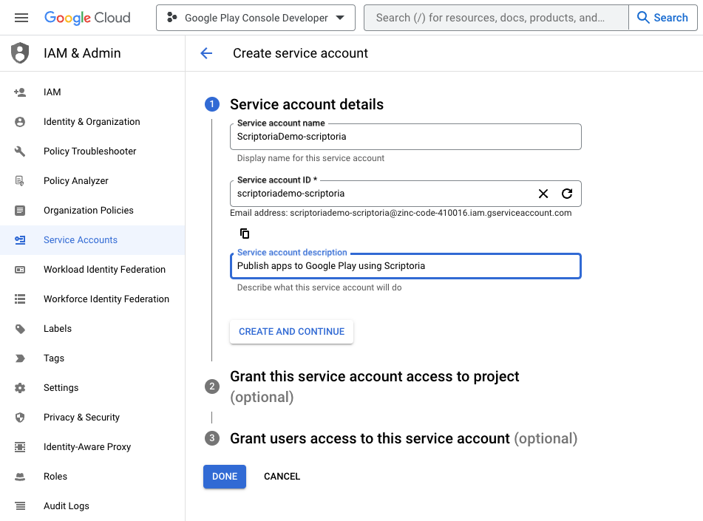
- Click on CREATE AND CONTINUE
- Set Grant this service account access to project (optional) to Basic > Owner

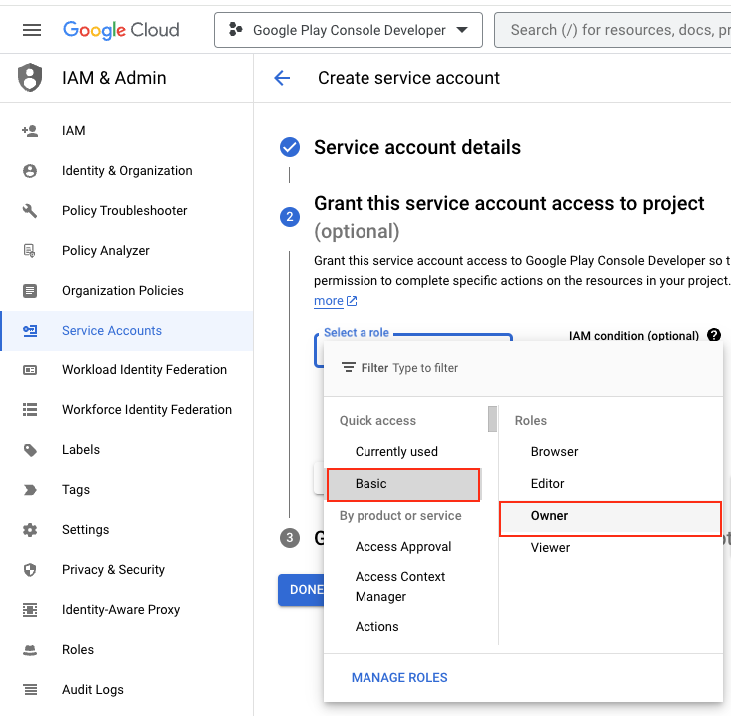
- Click on CONTINUE

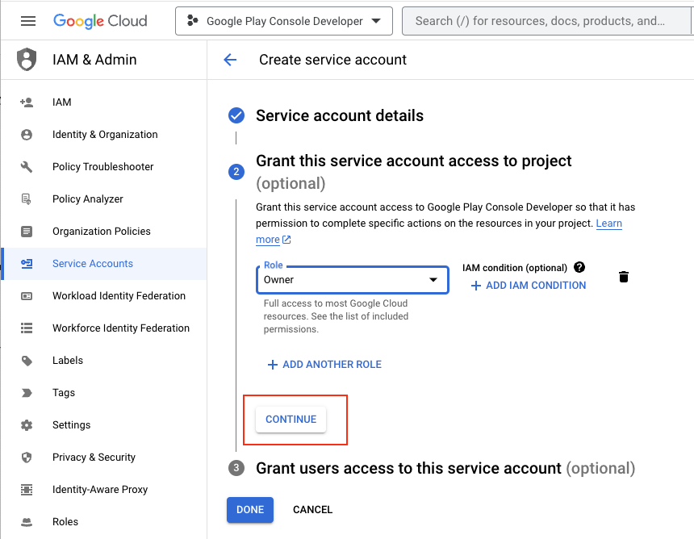

- Click on DONE
- On the row with the new service account, click on the vertical dot menu and click on Manage keys
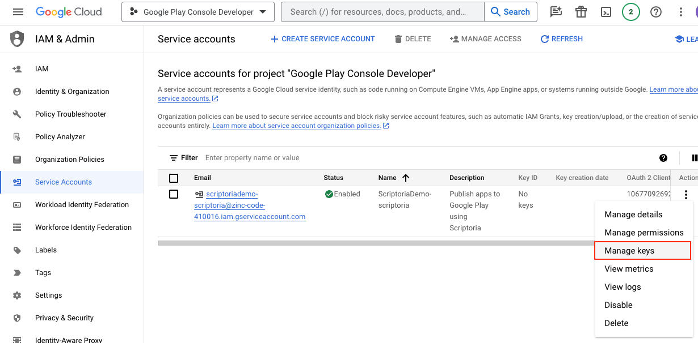

- On the Keys page, click ADD KEY and then Create new key

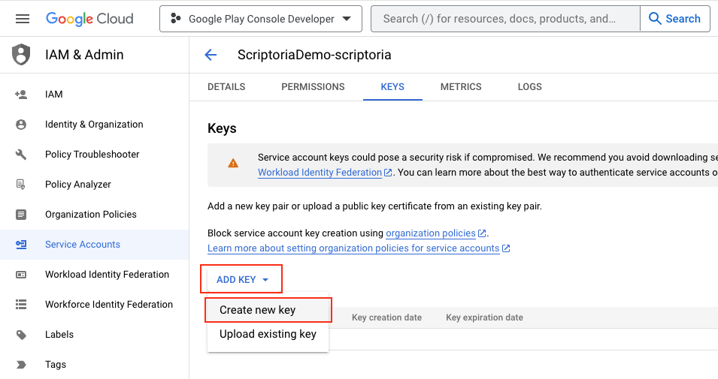

- Use JSON Key type (default) and click CREATE (which will prompt to save a JSON file with the Google Play API Key to your computer).
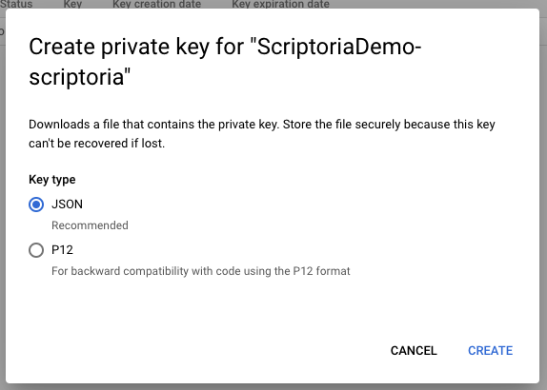
- Click Close on the Private key saved to your computer dialog.
- Click on the back arrow to go back to the list of Service accounts.

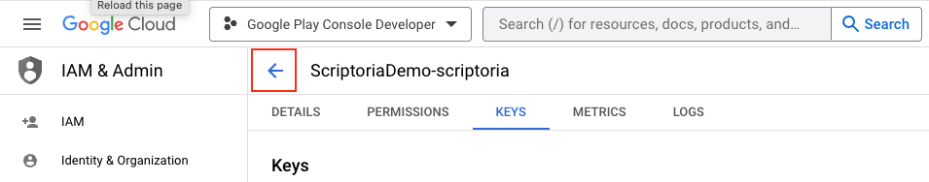

- Hover your mouse over the Email field of the new Service account and click on the copy icon to copy the email address of the service account.

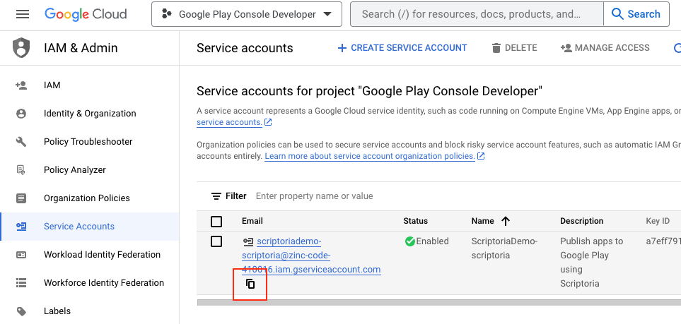

Invite Service Account to Google Play
Now that you have the service account created and the JSON API Key downloaded, you need to give permission to the service account in your Google Play console.

- Open the Google Play Developer Console (https://play.google.com/console/developers) for your Google Play Store.
- Go to the Users and permissions section
- Click on Invite new users button

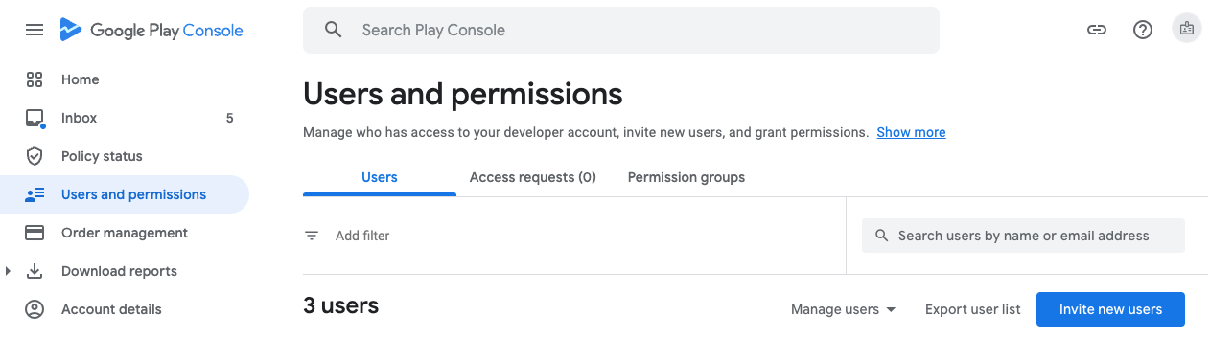

- Paste in the Email address of the service account into the Email address field.
- Select Account permissions tab and check Admin (all permissions)

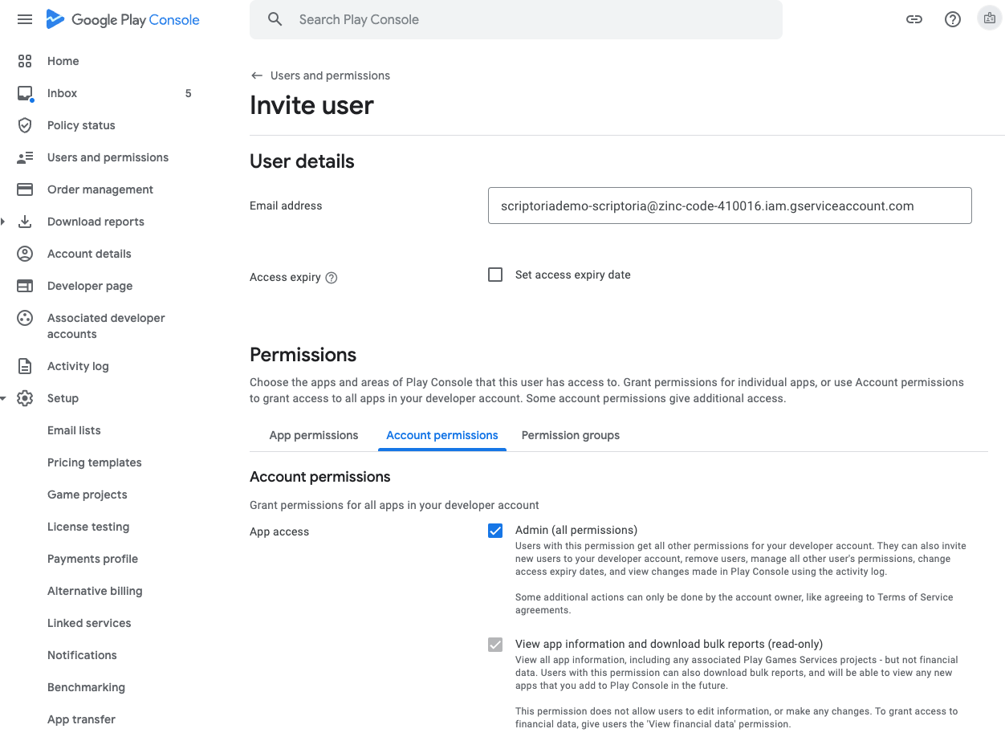
- Click the Invite user button at the bottom of the page.
- Click the Send Invite button in the Send invite? dialog box.

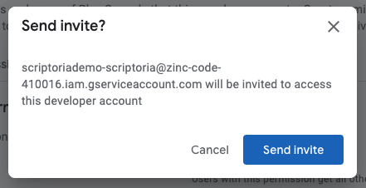

You will be redirected back to the Users and permissions list and will see the new entry for the service account email address with the Active status.

Send JSON API Key to Scriptoria
Email the JSON API Key file to the Scriptoria administrator who is assisting with the creation of your Scriptoria account.

